Output :-

Popup alert of index number.

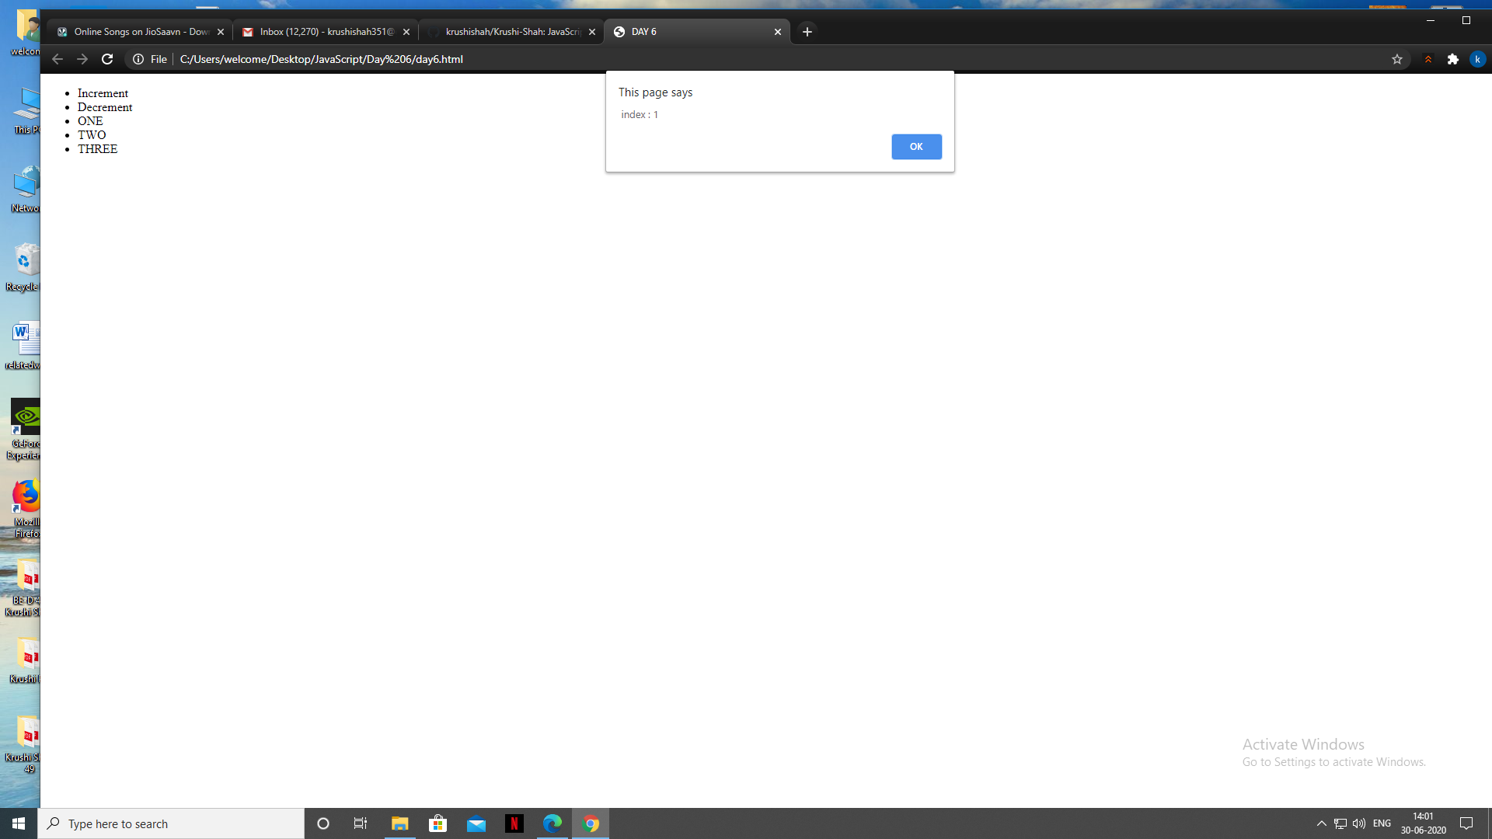

Increment and Decrement on clicking list elements increment and decrement and display the counter.

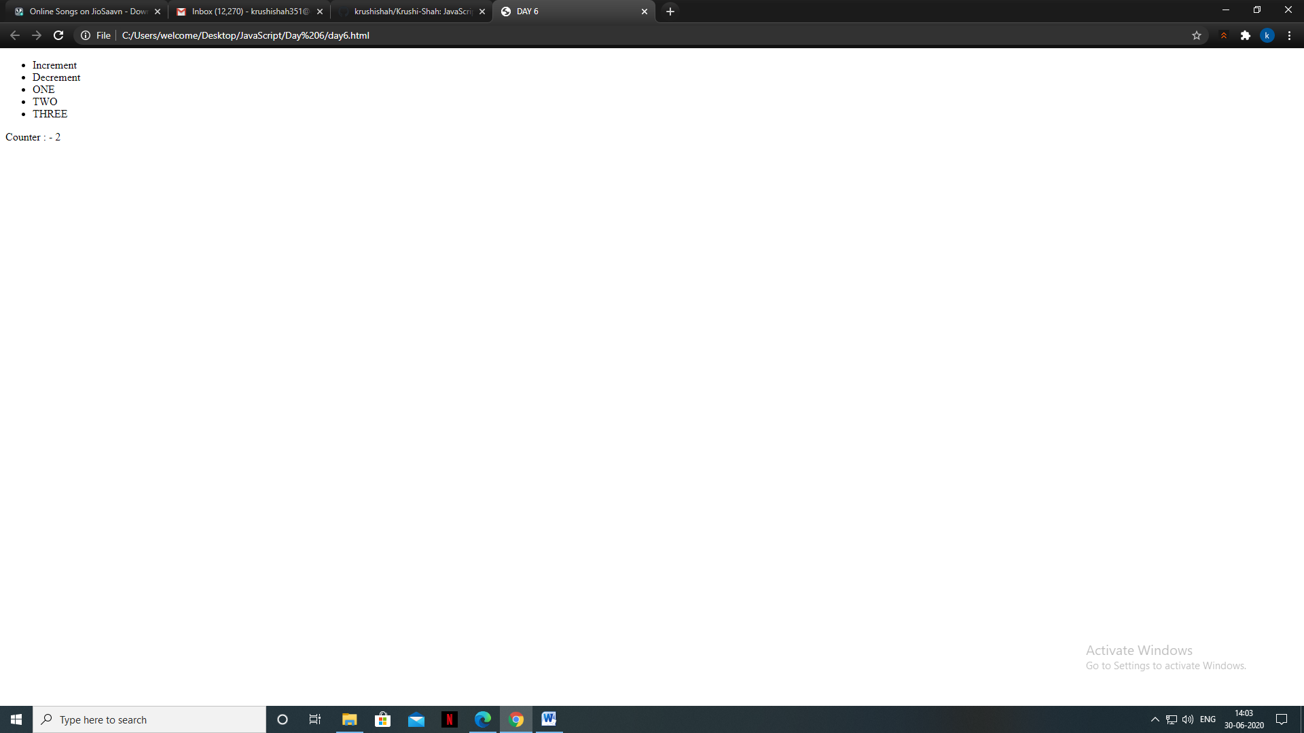

Inheritance

